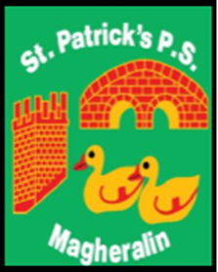

ST. PATRICK’S PRIMARY SCHOOL
12 Ballymacbredan Road, Magheralin, Craigavon. BT67 OQU
Tel no – 028 3834 1400 Fax no – 028 3834 7376
Email: info@stpatricks.magheralin.ni.sch.uk
Principal: Mrs. M. McGrath. BA(QTS), PQHSH, DipPD.
‘Together we learn, together we grow, developing our future, wherever we go!’

25th June 2020

Dear Parent

Due to social distancing guidelines in place, we ask that when collecting your child/ren’s report that as far as possible, only one adult comes to school.

We will operate a one-way system for collection, whereby you enter the school by the front door, proceed directly to the school hall and leave via the school hall exit.

We thank you in anticipation of your support of these measures for the health and safety of all.

Could I also remind you that if your child still has a school reading or library book at home that this is returned and placed into the container that is provided in the front entrance hall.

Primary 7 Parents
We ask that your Primary 7 child attends school with you and wears their full school uniform.
Please enter the hall during your allocated time to collect any reports for your younger children and then, weather permitting, proceed to the school playground.

We ask that all P7 children and parents arrive by 1:20pm at the latest.

Kind Regards

Mrs M. McGrath

