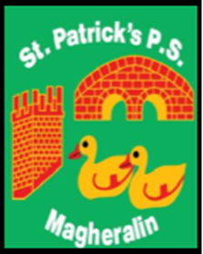

ST. PATRICK’S PRIMARY SCHOOL
12 Ballymacbredan Road, Magheralin, Craigavon. BT67 OQU
Tel no – 028 3834 1400 Fax no – 028 3834 7376
Email: info@stpatricks.magheralin.ni.sch.uk
Principal: Mrs. M. McGrath. BA(QTS), PQHSH, DipPD.
‘Together we learn, together we grow, developing our future, wherever we go!’

9th November 2020

Dear Parent

Prior to Halloween you received notification that we wanted to ascertain the level of interest to run a Homework club each day and an Eco/Gardening club on each Friday. We thank those parents who showed an interest in using such clubs for their children.

We would like to trial running these clubs from the week beginning Monday 16th November.

To run these afterschool clubs, we do need sufficient numbers of children to attend and club viability will be reviewed again at Christmas. The present COVID situation has left it difficult to run our clubs in the usual way, as we must pay close attention to our bubbles, social distancing and hygiene.

The Homework club will be available, Monday to Thursday from 2pm to 4pm. The Eco/Gardening club would run each Friday from 2pm to 3pm.

As in Breakfast and Drop Off clubs, it is our intention to keep the children in their ‘class bubbles’ within each club, socially distanced from each other’s bubble.

We ask that children bring wellington boots and an oversized shirt for the gardening club to protect their school footwear and clothing.

Those parents who indicated that their child would like to attend a club will have received a confirmation text this morning. If you have not received this text, please contact Una, in the office on Tuesday morning.

Please ensure that you book your child into the club one full week in advance to give the club notice. You must also wait for confirmation from the school office that your child’s booking can be accepted before your child attends. The cost will remain at £3.50 per hour for the afterschool clubs.

We thank you for your support in advance.

Yours sincerely

Mrs M. McGrath
Principal

