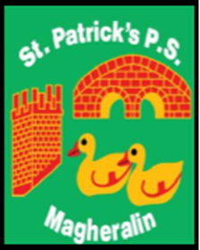

ST. PATRICK’S PRIMARY SCHOOL
12 Ballymacbredan Road, Magheralin, Craigavon. BT67 OQU
Tel no – 028 3834 1400 Fax no – 028 3834 7376
Email: info@stpatricks.magheralin.ni.sch.uk
Principal: Mrs. M. McGrath. BA(QTS), PQHSH, DipPD.
‘Together we learn, together we grow, developing our future, wherever we go!’

November 2020

Dear Parent,
This year we are continuing with our texting service and online money service to parents.

To support us in the cost of this very valuable and convenient service, we ask each family to contribute the sum of £15:00. This payment can be made using our online service. It can be made as £5 per term or as one payment. If this is paid in full during term one, a further payment for this service is not required this school year.
Payment can be made using our online service.
Please contact our school secretary, Mrs Una Hamill, if you require any support in accessing this.

During this term we are developing our new three-year School Development Plan and are highlighting areas that will require focus and investment. It is for this reason that we have not yet asked for Voluntary Contributions as we have previously done.
When our planning is complete, we will inform you of the area/s that will require our focus and funding support. We aim to provide you with more details in the second term.

All schools are facing very tough economic times ahead and are now, or already have been, requesting support from parents. We aim to always keep this to a minimum. We, as a school team, appreciate and value your support. It is our collective desire to provide the best education for the children of St. Patrick’s Primary School.

Yours sincerely,
Mrs. McGrath
Principal

