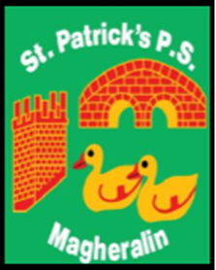

ST. PATRICK’S PRIMARY SCHOOL
12 Ballymacbredan Road, Magheralin, Craigavon. BT67 OQU
Tel no – 028 3834 1400 Fax no – 028 3834 7376
Email: info@stpatricks.magheralin.ni.sch.uk
Principal: Mrs. M. McGrath. BA(QTS), PQHSH, DipPD.
‘Together we learn, together we grow, developing our future, wherever we go!’

19th November 2020

Dear Parent

Christmas Dinner Day – Thursday 10th December

This year, due to covid restrictions, we have been unable to provide school meals for the whole school, as normal. However, after discussion with School Meals provision, it will be possible to provide a ‘fun Christmas dinner’.

This year’s Christmas dinner will take the form of a ‘Happy Meal’ style of food, of chicken nuggets and chips, rather than the traditional Christmas dinner usually offered. Dessert will be Christmas shortbread. All meals will be delivered to classrooms in individual disposable boxes/bags and children will remain in their class bubbles.

Christmas dinner will take place on Thursday 10th December. If you wish your child to avail of this Christmas party meal, this can be booked and paid for on the Eduspot school money system. The cost of the dinner is £2.60.

As with previous years, we plan to have our Christmas Jumper day on the same day, to add to the fun, festive atmosphere!

Yours sincerely
School Office

