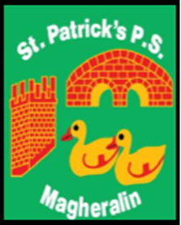

ST. PATRICK’S PRIMARY SCHOOL
12 Ballymacbredan Road, Magheralin, Craigavon. BT67 OQU
Tel no – 028 3834 1400 Fax no – 028 3834 7376
Email: info@stpatricks.magheralin.ni.sch.uk
Principal: Mrs. M. McGrath. BA(QTS), PQHSH, DipPD.
‘Together we learn, together we grow, developing our future, wherever we go!’

24th November 2020

Dear Parents

Christmas Raffle

This year, due to covid restrictions, our Christmas raffle will be done a little differently! Tickets can be purchased on Eduspot school money system in the School Shop section. This can be found by clicking the top left hand corner of the screen once you log in.

There are options to purchase 6 tickets for £5; 12 tickets for £10; or 20 tickets for £15. Just click on the option you require, and payment will be requested.

Rather than sending out the traditional book of tickets, this year your child’s name will be entered onto a numbered grid for each ticket you have purchased, then the draw will be made in the usual way by pulling out the winning tickets.

Prizes are: Christmas food hamper
£50 Farmgate Meats voucher
Wine & Cheese Hamper
£20 Lidl voucher
A large Cuddly Elf!

The draw will take place on Thursday 10th December 2020, during our Christmas fun day.

Yours sincerely
Mrs McGrath

