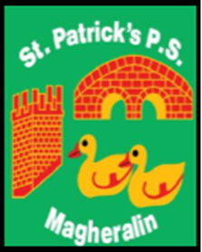

ST. PATRICK’S PRIMARY SCHOOL
12 Ballymacbredan Road, Magheralin, Craigavon. BT67 OQU
Tel no – 028 3834 1400 Fax no – 028 3834 7376
Email: info@stpatricks.magheralin.ni.sch.uk
Principal: Mrs. M. McGrath. BA(QTS), PQHSH, DipPD.
‘Together we learn, together we grow, developing our future, wherever we go!’

30th November 2020

Dear Parent

As we are all aware, this year has brought many changes to our lives and livelihoods. Not only do we have the serious issue of protecting our health, and that of our family members, against COVID19, but we also have the economic impact, and this has hit all families in many varied ways.

I have been approached by Mr Paul Martin, Youth Pastor in Magheralin Village Church, with a generous offer of support for families within our school community, who are in some need at this difficult time.

Mr Martin has stated that he is in the position to give our school 10 hampers, each containing £30 worth of food. The kind offer will be extended to families in receipt of Free School Meals first. However, any family in need will be considered in order of request.

Any request for a Hamper will be treated in the strictest of confidence.
Please reply directly to my email mmcgrath481@c2kni.net and we will arrange for you to collect your hamper, at a time which is suitable to you.

You must contact me by Thursday 3rd December to allow me to inform Mr Martin. The hampers will then be ready by 11th December, for collection.

Your sincerely

Mrs M McGrath
Principal

