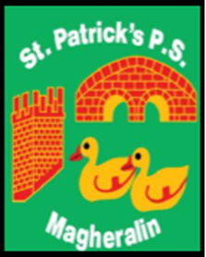

ST. PATRICK’S PRIMARY SCHOOL
12 Ballymacbredan Road, Magheralin, Craigavon. BT67 OQU
Tel no – 028 3834 1400 Fax no – 028 3834 7376
Email: info@stpatricks.magheralin.ni.sch.uk
Principal: Mrs. M. McGrath. BA(QTS), PQHSH, DipPD.
‘Together we learn, together we grow, developing our future, wherever we go!’

22nd December 2020

To our school community,

The school is now closing for the Christmas Holiday period and on behalf of the Board of Governors, I would like to wish you all a very Happy, healthy and safe Christmas.

I would also like to thank all our staff for their ongoing commitment to the school and to our children in these exceptional times and to assure you that the school places health and wellbeing of all in school, both adults and children, as the top priority at all times.

I would also like to thank you our parents for your ongoing support in what has been a very difficult and anxious year for everybody. To quote St. Therese, if we all “do the little things” this will not only help to keep us safe but also help to keep our family, friends and colleagues safe.

Have a happy, healthy and safe Christmas

Fiona Hamill
Chairperson of the Board of Governors of St Patrick’s Primary School.

