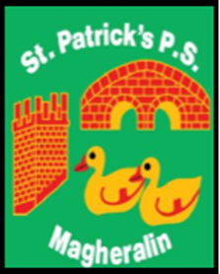

ST. PATRICK’S PRIMARY SCHOOL
12 Ballymacbredan Road, Magheralin, Craigavon. BT67 OQU
Tel no – 028 3834 1400 Fax no – 028 3834 7376
Email: info@stpatricks.magheralin.ni.sch.uk
Principal: Mrs. M. McGrath. BA(QTS), PQHSH, DipPD.
‘Together we learn, together we grow, developing our future, wherever we go!’

10th March 2021

Dear Parent
We have been delighted to welcome back our Reception to Primary 3 children from Monday of this week. It was a joy to see their smiling faces! They have all settled well back into school with their friends, teachers and assistants.
It is our great desire to keep our children, staff and parents safe and well during this period of return, with the greater hope of a more full return to schools by all of our children in the coming weeks.
To keep our school communities safe, we all have a role to play in ensuring that we follow all guidance and advice. Only this adherence to guidance and advice will ensure that our schools remain open, that more of our children can return to school and that our wider society can function more fully than it has been.
We therefore remind parents / carers of the following;

- Please use our one-way system around the school
- Children in classes Reception to Primary 3 should enter and exit school using the bottom (P2/3) and left side (Reception/P1) doors as they did during the first term.
- Parents / Carers should wear a face covering when they enter the school grounds
- Parents and carers should not stop to chat in the school grounds
- Parent and carers should ensure that the child they are bringing to/from school remains close to them at all times to avoid mixing with children from other classes.

Further to this we ask, that as far as is possible only one parent/carer brings their children to/from school as this will reduce the amount of people on site at any one time.
We appreciate all of your support to date. It is our desire to keep the school open and return all of our children to school as soon as is possible and it is only with your support that schools will be allowed to do this. Thank you in advance of your understanding.

Yours sincerely
Mrs M McGrath
Principal

