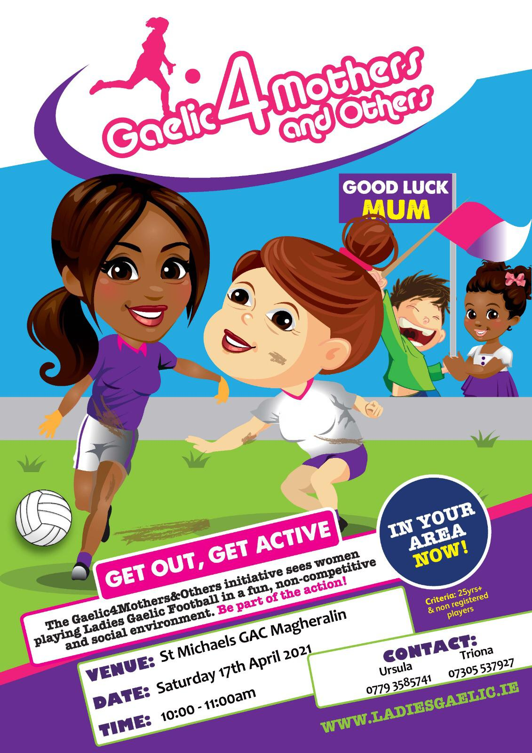

St. Michael’s GFC are starting a Gaelic4Mothers&Others initiative starting this Saturday 17th April 2021. It’s for all women 25yr+ interested in having a bit of craic and getting a bit of exercise! They don’t have to have ever played.....this is very much a social/fun thing 😀
POSTPONED DUE TO UNFORESEEN CIRCUMSTANCES. A NEW DATE WILL BE SENT OUT IN DUE COURSE.

