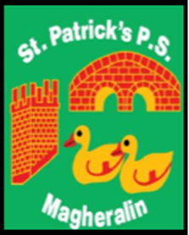

ST. PATRICK’S PRIMARY SCHOOL
12 Ballymacbredan Road, Magheralin, Craigavon. BT67 OQU
Tel no – 028 3834 1400 Fax no – 028 3834 7376
Email: info@stpatricks.magheralin.ni.sch.uk
Principal: Mrs. M. McGrath. BA(QTS), PQHSH, DipPD.
‘Together we learn, together we grow, developing our future, wherever we go!’

20th April 2021
Dear Parent
Below you will find a reminder of when the Sacraments will take place for children in Primary 4 and Primary 7.

Primary 4
First Confession – Tuesday 11th May at 7pm
Holy Communion – Sunday 6th June at 1pm

Primary 7
Confirmation – Thursday 6th May at 6pm
Please note that Fr McConville has informed us that the Service of Light has now been cancelled.

In order to adhere to social distancing regulations still currently in place, Fr McConville has also advised us of the following with reference to numbers attending each Sacrament.

- A maximum of SEVEN people can be permitted per family. This includes the child to receive the Sacrament.
- Each family will be allocated their seat on arrival by parish staff. It is asked that the family group arrive and are seated at the same time.
- Children receiving their Sacrament will sit with their families but must sit at the end of their seat at the aisle.

We thank you for your co-operation and look forward to celebrating these Sacraments with your children.

Yours sincerely
Mrs M McGrath
Principal

