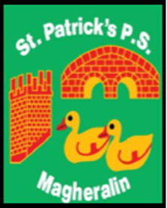

ST. PATRICK’S PRIMARY SCHOOL
12 Ballymacbredan Road, Magheralin, Craigavon. BT67 OQU
Tel no – 028 3834 1400 Fax no – 028 3834 7376
Email: info@stpatricks.magheralin.ni.sch.uk
Principal: Mrs. M. McGrath. BA(QTS), PQHSH, DipPD.
‘Together we learn, together we grow, developing our future, wherever we go!’

17th May 2021

Dear Parent

Provision of School Meals

This year to date, due to covid restrictions, we have been unable to provide school meals for the whole school, as normal.

However, after discussion and purchase of additional equipment with School Meals Service, it may now be possible to provide school meals for all children in our school for the remainder of the academic year.

In order to gauge numbers interested in availing of school meals, we would be grateful If you could email the school office stating your interest, and the days your child would be taking school meals. We would require this information by Thursday 20th May.

If there is any parent, guardian or relative that would like to work for the School Meals Service during this period of the school day, please pass your/their details to the school office.

Yours sincerely
School Office

