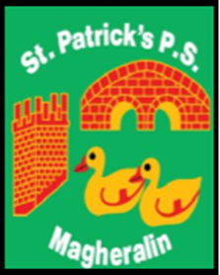

ST. PATRICK’S PRIMARY SCHOOL
12 Ballymacbredan Road, Magheralin, Craigavon. BT67 OQU
Tel no – 028 3834 1400 Fax no – 028 3834 7376
Email: info@stpatricks.magheralin.ni.sch.uk
Principal: Mrs. M. McGrath. BA(QTS), PQHSH, DipPD.
‘Together we learn, together we grow, developing our future, wherever we go!’

26th May 2021

Dear Parent

This week, an issue was found with the link to our school dinner menu. The dinner menus are sent to us from another school kitchen. Please be advised that the issue was NOT with any of our school links and that the issue has been rectified with school kitchens.

We thank you for your continued support.

Yours sincerely

M. McGrath
Principal

