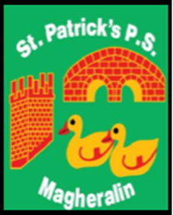

ST. PATRICK’S PRIMARY SCHOOL
12 Ballymacbredan Road, Magheralin, Craigavon. BT67 OQU
Tel no – 028 3834 1400 Fax no – 028 3834 7376
Email: info@stpatricks.magheralin.ni.sch.uk
Principal: Mrs. M. McGrath. BA(QTS), PQHSH, DipPD.
‘Together we learn, together we grow, developing our future, wherever we go!’

4th June 2021

Dear Parent
This year, due to continued COVID restrictions we will not be able to invite you all as parents to our annual Sports Day. Whilst we appreciate that this may be disappointing, the health and safety of our pupils, staff and wider community remains a priority.

However, we still intend to have a sports fun day in school, with our children remaining in their bubbles. This will take place on Wednesday 9th June, weather permitting.

We ask that all children wear their school jog bottoms or shorts on this day and bring a hat, raincoat and extra water. If the weather is forecast to be warm, we also ask that you apply sun cream to your child before they attend school on that morning.

We are delighted to be supported by Tesco, who will provide a fruit snack to each child on the day.

Yours sincerely

Mrs G. Magennis Mrs M. McGrath
PE Co-ordinator Principal

