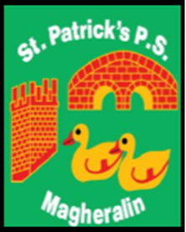

ST. PATRICK’S PRIMARY SCHOOL
12 Ballymacbredan Road, Magheralin, Craigavon. BT67 OQU
Tel no – 028 3834 1400 Fax no – 028 3834 7376
Email: info@stpatricks.magheralin.ni.sch.uk
Principal: Mrs. M. McGrath. BA(QTS), PQHSH, DipPD.
‘Together we learn, together we grow, developing our future, wherever we go!’

10th August 2021

Dear Parent/Guardian

I would like to confirm that children are able to bring their own school bags and stationery to school from September 2021. It is requested however, that each item is labelled with your child’s name. Lunch boxes and water bottles must also be clearly labelled.

Should EA advise of any change to this, we will inform you at our earliest opportunity.

Yours sincerely

Mrs M. McGrath
Principal

