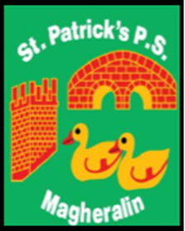

ST. PATRICK’S PRIMARY SCHOOL
12 Ballymacbredan Road, Magheralin, Craigavon. BT67 OQU
Tel no – 028 3834 1400 Fax no – 028 3834 7376
Email: info@stpatricks.magheralin.ni.sch.uk
Principal: Mrs. M. McGrath. BA(QTS), PQHSH, DipPD.
‘Together we learn, together we grow, developing our future, wherever we go!’

28th September 2021
Dear Parent

Travelling Books Book Fair – Thursday 30th September – Friday 1st October

Due to covid restrictions, this year’s Book Fair will be a little different!

Unfortunately, we are unable to invite our parents into school to browse the books. However, each class will be given the opportunity to look at the books, and a “My Book Fair Wish List” will be completed by children who wish to purchase a book.

If you would like to purchase some/all of these wish list books, parents can pay securely online using a unique link just for our school. The instructions for doing so are below.

- Once you’ve selected your books, visit travellingbooks.co.uk/pay and enter the school’s name or postcode (BT67 0QU).
- Then follow the instructions below
- On the Travelling Books website, select ‘I am paying for books from a Wish List’.
- Enter your details, along with the total amount you are paying for your books.
- Once payment is complete, forward your payment reference and details of the books you have purchased to us at school.

Parents must not order books through the online shop, as the school will not receive commission for them. Orders must be done through the Wish List detailed above.

Yours sincerely

School Office

