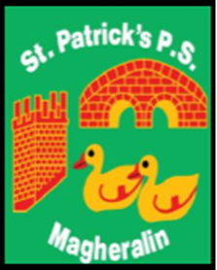

ST. PATRICK’S PRIMARY SCHOOL
12 Ballymacbredan Road, Magheralin, Craigavon. BT67 OQU
Tel no – 028 3834 1400 Fax no – 028 3834 7376
Email: info@stpatricks.magheralin.ni.sch.uk
Principal: Mrs. M. McGrath. BA(QTS), PQHSH, DipPD.
‘Together we learn, together we grow, developing our future, wherever we go!’

3rd November 2021

Dear Parent / Guardian
On behalf of the Gardening Club I would like to thank, Mr. Thomas Hamill, for donating compost, bulbs and seeds, and also Mrs. Clare Catney for the beautiful apple tree the children planted last month.
I would also like to thank parents who have donated quality, preloved, books to school. This enriches class libraries.
The school has also received a private donation of £1000, for which we would like to thank the donor. We were able to put this very generous donation towards a new whole school interactive Literacy resource.
All donations are most gratefully received and are used to enhance your children’s experiences at school.

With gratitude,
Mrs. M. McGrath
Principal

