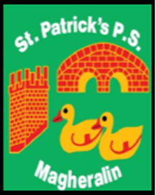

ST. PATRICK’S PRIMARY SCHOOL
12 Ballymacbredan Road, Magheralin, Craigavon. BT67 OQU
Tel no – 028 3834 1400 Fax no – 028 3834 7376
Email: info@stpatricks.magheralin.ni.sch.uk
Principal: Mrs. M. McGrath. BA(QTS), PQHSH, DipPD.
‘Together we learn, together we grow, developing our future, wherever we go!’

November 2021

Dear Parent,

Monday 15th November marks the beginning of Anti-Bullying week. During this week, in our classes, we will have opportunities to discuss how we can reduce bullying together. Throughout the week the children will read and discuss stories and watch videos in class that will explore this important issue.

To mark the beginning of this very important week, we will participate in
ODD Socks Day on Monday 15th November.
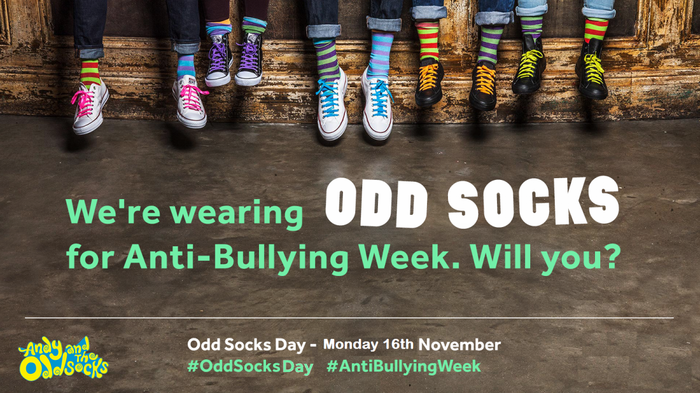

Each child, and adult too, can wear odd socks to school. Odd socks day is designed to be fun! ‘It is an opportunity for children to express themselves and celebrate their uniqueness.’

Yours sincerely,
Mrs. McGrath
Principal

