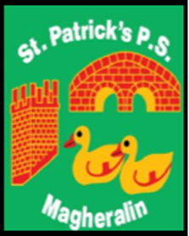

ST. PATRICK’S PRIMARY SCHOOL
12 Ballymacbredan Road, Magheralin, Craigavon. BT67 OQU
Tel no – 028 3834 1400 Fax no – 028 3834 7376
Email: info@stpatricks.magheralin.ni.sch.uk
Principal: Mrs. M. McGrath. BA(QTS), PQHSH, DipPD.
‘Together we learn, together we grow, developing our future, wherever we go!’

3rd December 2021

Dear Parents

I am writing to inform you that as a direct result of the Covid-19 pandemic, there are unprecedented pressures on both teaching and non-teaching staff within schools across the entire education system in Northern Ireland.

As a result, there is a significant shortage of available substitute teachers across all sectors and many schools are finding that securing substitute teachers for their classes has become impossible.

We will of course, do all we can to ensure that our classes remain open, however, in the event of unsafe staffing levels, we will have no alternative but to temporarily close a class or classes.

We sincerely hope that this will not happen, but with the current situation in schools, we must be prepared. Therefore, we ask that you ensure that your childcare arrangements are in place should a class or classes be required to close at short notice.

In the event that we need you to keep your child at home, you will be notified by the school texting service.

To allow us all to remain at school for as many days as is possible we ask all parents to ensure that your child is kept off school should they show any of the following symptoms;

- a high temperature, or;

- a new, continuous cough – this means coughing a lot for more than one hour, or three or more coughing episodes in 24 hours (if you usually have a cough this could be worse than usual), or;

-anosmia – the loss or change in your normal sense of smell (it can affect your sense of taste).

Thank you in advance for your support.

Yours sincerely

Mrs M. McGrath
Principal

