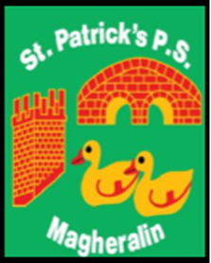

ST. PATRICK’S PRIMARY SCHOOL
12 Ballymacbredan Road, Magheralin, Craigavon. BT67 OQU
Tel no – 028 3834 1400 Fax no – 028 3834 7376
Email: info@stpatricks.magheralin.ni.sch.uk
Principal: Mrs. M. McGrath. BA(QTS), PQHSH, DipPD.
‘Together we learn, together we grow, developing our future, wherever we go!’

6th December 2021

Dear Parent

As the Christmas holiday period approaches, many of you will be looking forward to spending some much needed and valued time with family members. I am however aware of growing concerns among parents, in this and in wider school communities, as to the growing infection rates of COVID.

We are aware that families are considering the option of protecting their family bubble in time for Christmas, by reducing as many outside of home interactions as is possible. I am conscious that a positive case of Covid 19 in the school community could mean, that pupils and families are required to self-isolate over Christmas day.

After consulting with the Board of Governors, it is agreed that any parent wishing to keep their child/ren at home from Monday 13th December, to protect their family bubble, may do so.

The last school full week and a half leading up to Christmas often lends itself to finishing off specific work, revision work and or Christmas themed activities. Work will be placed on to SeeSaw for classes P1 to P3 and on to Google classroom for Classes P4 to P7. Please ensure that your children can access their accounts.

As teachers will still be required to teach in school, we ask that this work is marked at home and sent back to their teacher to view and comment on a daily basis.

School will however remain open until our planned closure on 22nd December at 12 noon.

Yours sincerely

Mrs M. McGrath
Principal

