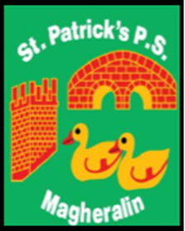

ST. PATRICK’S PRIMARY SCHOOL
12 Ballymacbredan Road, Magheralin, Craigavon. BT67 OQU
Tel no – 028 3834 1400 Fax no – 028 3834 7376
Email: info@stpatricks.magheralin.ni.sch.uk
Principal: Mrs. M. McGrath. BA(QTS), PQHSH, DipPD.
‘Together we learn, together we grow, developing our future, wherever we go!’

18th January 2022

Dear Parents

As part of our measures to help mitigate against the spread of Covid-19 in our school community, we have been advised to keep rooms well ventilated by opening classroom doors and windows at intervals. The measures advised, understandably, can lead to a drop in room temperature.

Given the time of year we are currently in, we would encourage all students to wear non-visible base layers under their normal school uniform and their PE uniform. It is also recommended that our girls wear tights during the winter months.

We thank you for your continued support.

Yours sincerely

Mrs M. McGrath
Principal

