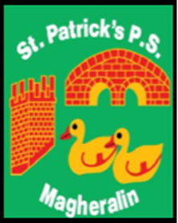

ST. PATRICK’S PRIMARY SCHOOL
12 Ballymacbredan Road, Magheralin, Craigavon. BT67 OQU
Tel no – 028 3834 1400 Fax no – 028 3834 7376
Email: info@stpatricks.magheralin.ni.sch.uk
Principal: Mrs. M. McGrath. BA(QTS), PQHSH, DipPD.
‘Together we learn, together we grow, developing our future, wherever we go!’

11th April 2022

Dear Parent

Primary 3 – Summer Term Finish time

As previously advised, Primary 3 children will remain in school until 3pm Monday – Thursday for the Summer term.

All children will continue to go home at 2pm each Friday.

Please note this takes effect from Monday 25th April 2022.

Please ensure that anyone involved in your child’s care/collection arrangement, is aware of this change of time.

We will send a reminder via text.

Yours sincerely

Mrs M. McGrath
Principal

