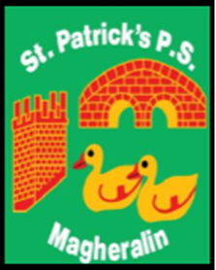

ST. PATRICK’S PRIMARY SCHOOL
12 Ballymacbredan Road, Magheralin, Craigavon. BT67 OQU
Tel no – 028 3834 1400 Fax no – 028 3834 7376
Email: info@stpatricks.magheralin.ni.sch.uk
Principal: Mrs. M. McGrath. BA(QTS), PQHSH, PGDip.
‘Together we learn, together we grow, developing our future, wherever we go!’

24th May 2022

Dear Parent

Each Wednesday from tomorrow (25th May), until the end of term, we intend to Trial a ‘Lego Club’ for Primary 1 and 2 children from 2 – 3pm in our afterschool.

Should you wish your child to attend, please book them in and make your payment using the Eduspot App in the normal way to access our after school.

Thank you

School Office

