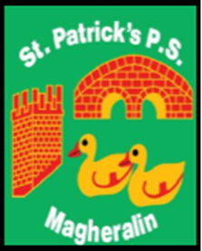

ST. PATRICK’S PRIMARY SCHOOL
12 Ballymacbredan Road, Magheralin, Craigavon. BT67 OQU
Tel no – 028 3834 1400 Fax no – 028 3834 7376
Email: info@stpatricks.magheralin.ni.sch.uk
Principal: Mrs. M. McGrath. BA(QTS), PQHSH, DipPD.
‘Together we learn, together we grow, developing our future, wherever we go!’

September 2022

Dear Parent

We are delighted to have again accessed the Down GAA Coaching Programme in our school for children in Primary 4, 5/6 and 7. Schools accessing this valuable programme are charged for this support.

Our programme is being delivered on Wednesdays, during school hours, beginning Wednesday 21st September until the end of January 2023, and we ask for £10 per child to cover the cost.

You can pay the amount using our online service.

Please ensure that your child wears their PE uniform to school on each Wednesday.

Thank you in advance for your support.

Mrs McGrath Mrs Magennis

PRINCIPAL PE Co-ordinator

