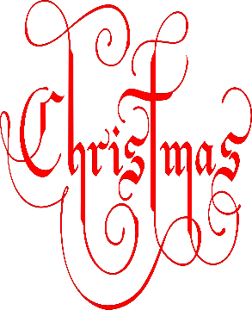
Christmas Raffle 2022
Prize list!!

- 1 Night’s Dinner, Bed & Breakfast at the Grand Central Hotel, Belfast.
- £100 Voucher for Wine and Brine, Moira
- £50 O’Neill’s Voucher
- £40 Voucher Farmgate Meats, Magheralin
- Wine and Cheese Hamper
- £20 Lidl Voucher
- Perfect Desserts Voucher
- Bottles of wine from Byrne’s Bar, Magheralin

Tickets available to purchase on Eduspot!
6 tickets £5 14 tickets £10 20 tickets £15

