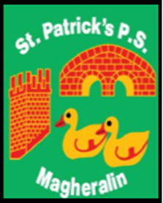

ST. PATRICK’S PRIMARY SCHOOL
12 Ballymacbredan Road, Magheralin, Craigavon. BT67 OQU
Tel no – 028 3834 1400 Fax no – 028 3834 7376
Email: info@stpatricks.magheralin.ni.sch.uk
Principal: Mrs. M. McGrath. BA(QTS), PQHSH, DipPD.
‘Together we learn, together we grow, developing our future, wherever we go!’

1st December 2022

Dear Parent

On Wednesday 7th December at 7pm, the children of St Patrick’s Primary School will present their school Christmas Nativity, ‘Teach the Children’, which will be held in the Chapel of
Ss Patrick and Ronan.

The children and their teachers and assistants have been working very hard and look forward to presenting this beautiful Nativity scene.

After the Nativity, we would like to invite you all into the parish hall for a cup of tea, to spend just a little time together, in the midst of this very busy time of year for all of our families.

We look forward to seeing you all there.

Yours sincerely

Mrs. McGrath

