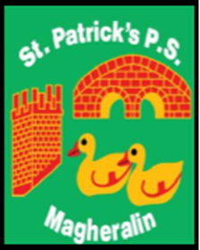

ST. PATRICK’S PRIMARY SCHOOL
12 Ballymacbredan Road, Magheralin, Craigavon. BT67 OQU
Tel no – 028 3834 1400 Fax no – 028 3834 7376
Email: info@stpatricks.magheralin.ni.sch.uk
Principal: Mrs. M. McGrath. BA(QTS), PQHSH, DipPD.
‘Together we learn, together we grow, developing our future, wherever we go!’

12th December 2022

Dear Parent

I would like to thank you all for your wonderful support in attending our Christmas nativity celebration ‘Teach the Children’. The boys and girls of St. Patrick’s Primary school were a credit to all!

On the evening, we had the performance videoed for school use. We hope to put this on to our Facebook and Webpage for viewing before Christmas.

If you would like a copy of the performance, which will come in DVD format along with a digital version, which will be password protected and sent directly to your email address, please contact the school office. Please note that you are unable to share the digital version. When ordering you must provide the school office with an email address for the digital version.
The cost of the DVD and digital performance is £9:00. You will be able to purchase this via Eduspot from 9:00am tomorrow morning.

Yours sincerely,
Mrs. McGrath
Principal

