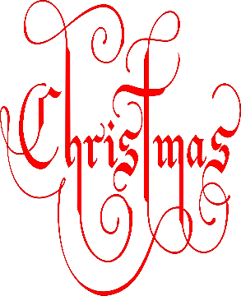
Christmas Raffle 2022

Prize Winners!!

- 1 Night’s Dinner, Bed & Breakfast at the Grand Central Hotel, Belfast.
Matthew Stevenson
- £100 Voucher for Wine and Brine, Moira
Ally-Rose Mitchell
- £50 O’Neill’s Voucher
Elliot Drake
- £40 Voucher Farmgate Meats, Magheralin
Matthew Todd
- Wine and Cheese Hamper
Tim IJpelaar
- £20 Lidl Voucher
Tim IJpelaar
- Perfect Desserts Voucher
Anna Cushnahan
- Bottle of wine from Byrne’s Bar, Magheralin
Eabha Brogan & Jack McCann
- Giant Cuddly Christmas Elf!
This Photo by Unknown Author is licensed under CC BY-NC
Eoin Hagan

Thank you all for your wonderful support!

