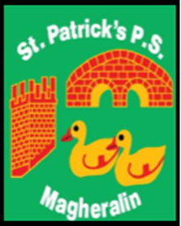

ST. PATRICK’S PRIMARY SCHOOL
12 Ballymacbredan Road, Magheralin, Craigavon. BT67 OQU
Tel no – 028 3834 1400 Fax no – 028 3834 7376
Email: info@stpatricks.magheralin.ni.sch.uk
Principal: Mrs. M. McGrath. BA(QTS), PQHSH, DipPD.
‘Together we learn, together we grow, developing our future, wherever we go!’

3rd March 2023

Dear Parent / Guardian

St Michael’s GAC’s St Patrick’s Day Event Committee, are planning another wonderful, fun, celebratory St. Patrick’s Day, on Friday 17th March 2023!

They are hoping that as many people as possible, throughout the community, can celebrate with them on the day. The parade will leave from Ss Patrick and Ronan’s carpark at 12noon!

You can participate in the following ways

1. Take part in the parade – Dress up in the St Patrick’s Day theme and have fun!

2. Participate in an open mic event - Our talented pupils can take part by singing or playing a musical instrument - preferably an Irish song/music

3. Or simply turn up an enjoy the family filled fun day!

If you would like to participate in the open mic event, or know someone who would, please contact the committee on 07989 741877.

Kind regards

Mrs M McGrath
Principal

