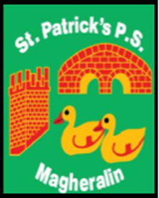

ST. PATRICK’S PRIMARY SCHOOL
12 Ballymacbredan Road, Magheralin, Craigavon. BT67 OQU
Tel no – 028 3834 1400 Fax no – 028 3834 7376
Email: info@stpatricks.magheralin.ni.sch.uk
Principal: Mrs. M. McGrath. BA(QTS), PQHSH, DipPD.
‘Together we learn, together we grow, developing our future, wherever we go!’

12th June 2023

Dear Parent/Guardian

As you are aware, Mrs Anne Mellors has retired this year from her post in our school. We were recently able to celebrate with Anne at school and wish her a wonderful retirement.
Due to Anne’s retirement, and subject to final ratifications by EA, we are to welcome Mrs Lisa Lach, to our school as Classroom Assistant from September. We all look forward to working with Lisa and hope that she enjoys her time in St Patrick’s Primary School.

Further to this, I wish to inform you that Mrs Una Hamill will resign from her post as School Secretary from July 2023. She will however, remain in her role as Drop Off assistant at 8:30am each morning.
Again, subject to final ratifications by EA, our School Secretary will be Mrs Laura Kane. Mrs Kane will begin working in the office, with Una, from Monday 26th June.

We look forward to welcoming both Lisa and Laura to the team at St Patrick’s.

Yours sincerely
Mrs McGrath
Principal

