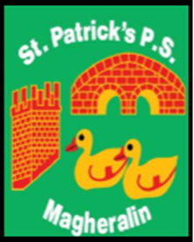

ST. PATRICK’S PRIMARY SCHOOL
12 Ballymacbredan Road, Magheralin, Craigavon. BT67 OQU
Tel no – 028 3834 1400 Fax no – 028 3834 7376
Email: info@stpatricks.magheralin.ni.sch.uk
Principal: Mrs. M. McGrath. BA(QTS), PQHSH, DipPD.
‘Together we learn, together we grow, developing our future, wherever we go!’

9th October 2023

Dear Parent,

We are delighted to welcome back the Scholastic Book Fair to our school next week.

Parents are invited to come along to the Resource Room and purchase books on:

Wednesday 18th October - 2pm – 3pm
Thursday 19th October - 9am - 9:30am and 2pm-3pm
Friday 20th October - 9am -9:30am and 2pm-3pm

Children from classes P4,5,6 & 7 will have an opportunity to purchase books on the morning of Thursday 19th and Friday 20th October.

I hope you will come along to support this book fair as the school gets a percentage of the sales. This amount, no matter how small, goes towards Literacy reading resources for our school.
It would be greatly appreciated to have cash payments only.

Thank you

_________
Miss K. Oliver
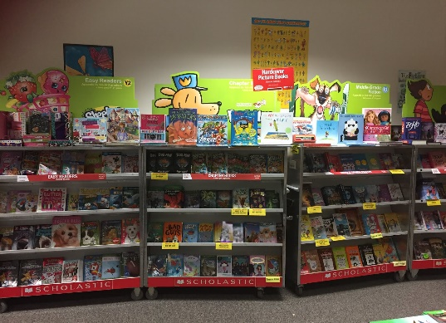
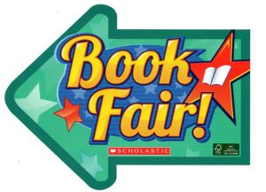
Literacy Coordinator
This Photo by Unknown Author is licensed under CC BY

