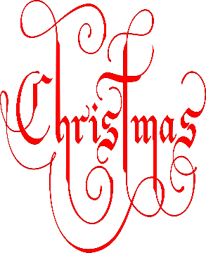
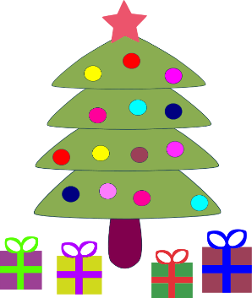
Christmas Raffle 2023

Prize Winners!!

- Overnight Night stay with dinner at the Grand Central Hotel, Belfast.
Fionn Kavanagh
- £100 Voucher for Wine and Brine, Moira
Martha Catney
- Sparkling Afternoon Tea at Edenmore
Erin Logan
Mud Ireland Pottery Experience Voucher
Eimear Mulvenna
- 1 month unlimited Gym membership at Murchu MovementFunctional Fitness Gym Cara Kavanagh
- £30 O’Neill’s Voucher
Joni Veltom
- £30 Smyth’s Toy Voucher
Eva Gray
- Book Cushions, with books, created by Maureen McCann
Eabha Brogan, Eva Gray, Toby Mullan & Michael Scullion
- Bottle of Rose wine
Luke Murphy
- Bottle of Mulled Wine
Martha Catney
Tin of Shortbread
Erin Monaghan
- Giant Cuddly Christmas Elf!
James Judge
Thank you all for your wonderful support!

