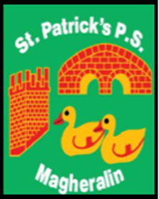

ST. PATRICK’S PRIMARY SCHOOL
12 Ballymacbredan Road, Magheralin, Craigavon. BT67 OQU
Tel no – 028 3834 1400 Fax no – 028 3834 7376
Email: info@stpatricks.magheralin.ni.sch.uk
Principal: Mrs. M. McGrath. BA(QTS), PQHSH, DipPD.
‘Together we learn, together we grow, developing our future, wherever we go!’

December 2018

Dear Parents
Once again, as in previous years, we are holding our annual Christmas raffle, with all proceeds going into school funds. Raffle tickets will be sold at £1:00 per ticket or £5:00 per book. We will be sending two books home to each family shortly.

All donations to the raffle will be greatly appreciated.
You have been very supportive and generous in previous years and we hope that this will continue.
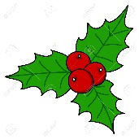
The raffle draw will take place on Thursday 20th December!

Yours sincerely
Mrs McGrath

1st Prize | Christmas Hamper
2nd Prize | Wine and Cheese Basket
3rd Prize | Meat Voucher

