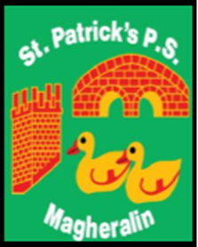

ST. PATRICK’S PRIMARY SCHOOL
12 Ballymacbredan Road, Magheralin, Craigavon. BT67 OQU
Tel no – 028 3834 1400 Fax no – 028 3834 7376
Email: info@stpatricks.magheralin.ni.sch.uk
Principal: Mrs. M. McGrath. BA(QTS), PQHSH, DipPD.
‘Together we learn, together we grow, developing our future, wherever we go!’

11th January 2019

Dear Parent
School Admissions 2019
The Education Authority (EA) recognises the need to provide Assisted Digital Support for some parents/guardians who want to apply online for a pre-school or primary place. The EA is hosting a number of Digital Admission Clinics.
The clinics will operate on a drop in basis and parents will be assisted in making their online application for a pre-school or primary place.
Details of clinics are available on the EA website under ‘Admissions’ www.eani.org.uk/clinicsforparents The schedule will be updated regularly as further clinics are arranged.
The following session has been arranged for Craigavon area on Monday, 14 January
DATE: Monday, 14 January 2019
VENUE: Moylinn Resource Centre, 21 Legahory Court, Craigavon BT65 5BE
TIME: 10.00 am - 12.30 pm
Thank you for considering St Patrick’s Primary School for your child.
Yours sincerely

Mrs M. McGrath

