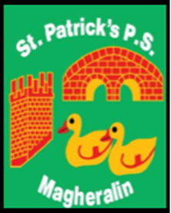

ST. PATRICK’S PRIMARY SCHOOL
12 Ballymacbredan Road, Magheralin, Craigavon. BT67 OQU
Tel no – 028 3834 1400 Fax no – 028 3834 7376
Email: info@stpatricks.magheralin.ni.sch.uk
Principal: Mrs. M. McGrath. BA(QTS), PQHSH, DipPD.
‘Together we learn, together we grow, developing our future, wherever we go!’

7th February 2019
Dear Parent
World Book Day 2019
World Book Day takes place on Thursday 7th March. As part of our celebrations this year, we plan to take our Reception to Primary 4 classes to the theatre on Wednesday 6th March.
Milo’s Hat Trick, written by Jon Agee, is being staged at Armagh’s Market Place Theatre. This is a perfect introduction to theatre for young children and we can expect a wonderful production with magic, music and mischief.
The show is during school hours, leaving school at approximately 9.15am returning for dinner at 12.15pm. The cost for each child is £10.30 which includes entry and bus travel. If you wish your child to attend please pay this online on our school money system by Friday 15th February.
I would also appreciate if you could return the permission slip by tomorrow, Friday 8th February to allow permission for your child to attend.
Yours sincerely

Miss K Oliver Vice Principal
--------------------------------------------------------------------------------------------------------------------------------------Permission Slip
I do/do not (please delete) give permission for my child (name)_____________________________ to attend Milo’s Hat Trick at Armagh Market Place on Wednesday 6th March.
I do/do not give (please delete) permission for my child to be photographed at the event.

Parent Signature_________________________________________Date_______________________

