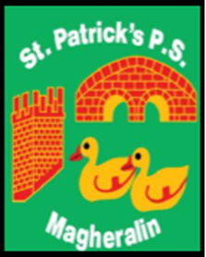

**ST. PATRICK’S PRIMARY SCHOOL**

**12 Ballymacbredan Road, Magheralin, Craigavon. BT67 OQU**

**Tel no – 028 3834 1400 Fax no – 028 3834 7376**

**Email: info@stpatricks.magheralin.ni.sch.uk**

**Principal: Mrs. M. McGrath. BA(QTS), PQHSH, DipPD.**

**‘Together we learn, together we grow, developing our future, wherever we go!’**



7th March 2019

Dear Parent

**Green Hamper Raffle**

As part of our St Patrick’s Day celebrations, parents and children have a chance to win our fantastic St Patrick’s Day Hamper.

The hamper contains over £50 worth of goodies along with gift vouchers donated by The Still House Restaurant, Captain Greens Adventure Golf, The Gallery, Karan Francis Beauty and Skechers (donated by Healthy Kidz.)

The raffle will take place next Friday 15th March. Please see attached a ticket sheet for you to have a chance to win this amazing prize.

|  |
| --- |
| Tickets Cost:  £1.00 Each  £5.00 for 6  £10.00 for 15 |

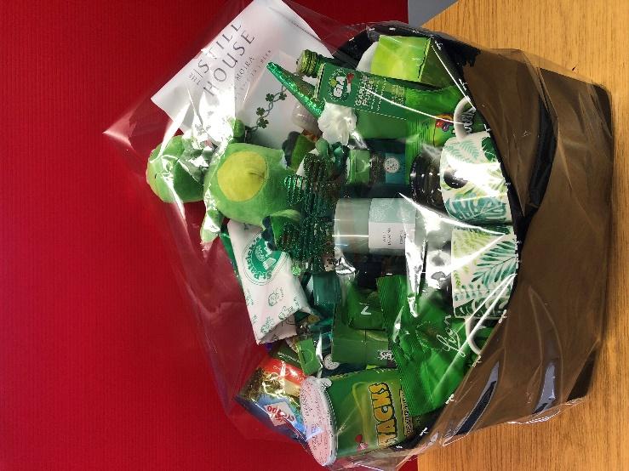

If you need any more tickets, please contact the school office. Any funds raised will be used for school resources and we appreciate your continued support for our school.

Yours sincerely

Mrs M. McGrath

Principal