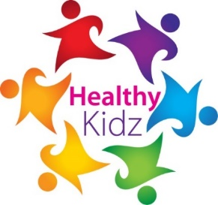

September 2019
R.E –Healthy Kidz Afterschool Clubs
Dear Parent/Guardian,
This new school year we are delighted that Healthy Kidz will be again in your school. Healthy Kidz is a schools coaching programme currently being delivered in over 130 schools. Their aim is to get every child Active, Fit and Healthy through a multi-strand approach, led by a Physical Activity Leader, dedicated to our school. Strands include weekly PE lessons, Golden Mile implementation, access to their APP physical Activity Log, Afterschool sessions, Emotional Intelligence + Mindfulness programme and their NET initiative (Nutrition, Eyes, Ears, Teeth). For further information please visit the HK website www.healthy-kidz.com or find through a search on facebook.
St Patrick’s P.S. has committed to the following level of coaching in an effort to improve the health and well-being of each child participating:
Primary 1 to 4 weekly PE sessions on Thursdays during school time
Tuesdays afterschool Sports club 2-4pm – Sports to include: Dodgeball - Rugby – Athletics - Fitness – Hockey – Hurling / Camogie - American Football - Volleyball - Children’s Choice!
- 2-3pm Sports Club for P1-3
3-4pm Sports Club P4-7
Wednesdays afterschool Dance club 2-4pm – The children received a taster of this at their recent assembly and it was very well-received. Please note that coaches will collect and return your child to school for this club as it will take place in St Michael’s GAC club.
- 2-3pm Dance Club for P1-3
3-4pm Dance Club P4-7

Each afterschool session will cost £3.00 and this is to be paid up front to ensure a place (places are limited); sessions will run for 12 weeks. In order to book your child’s place please follow the link
https://stpatrickspsmagheralinafterschools.eventbrite.co.uk
Yours sincerely,
Healthy Kidz

