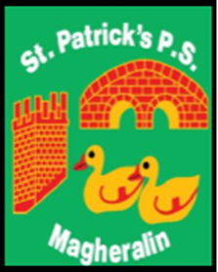

ST. PATRICK’S PRIMARY SCHOOL
12 Ballymacbredan Road, Magheralin, Craigavon. BT67 OQU
Tel no – 028 3834 1400 Fax no – 028 3834 7376
Email: info@stpatricks.magheralin.ni.sch.uk
Principal: Mrs. M. McGrath. BA(QTS), PQHSH, DipPD.
‘Together we learn, together we grow, developing our future, wherever we go!’

18th September 2019

Dear Parent

We have been made aware in school that a ‘TikTok’ profile/account, has been set up in a staff member’s name. This account is not associated to any member of staff. We have reported this case directly to the provider.
Please advise your children that they will NEVER be sent an ‘add friend’ request from any member of staff and they should therefore ignore/block any such request, make adults aware of them and choose the ‘report’ option in any social media site.
This is a timely reminder that we should remind our children that they should always ‘know’ exactly who they are connecting with online.
We all have a responsibility to ensure that our children are safe on line and that what we post online will always remain in the public domain for others to view.
We are all aware that all areas of social media are vulnerable to ‘fake’ accounts being set up and it is important to keep this conversation open with our children.
The online line world is moving rapidly forward and can be responsibly enjoyed, however the safety and integrity of all, is paramount.

We thank you in advance for your support.
Mrs M. McGrath

