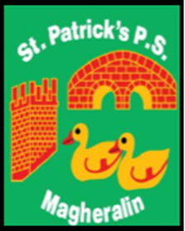

ST. PATRICK’S PRIMARY SCHOOL
12 Ballymacbredan Road, Magheralin, Craigavon. BT67 OQU
Tel no – 028 3834 1400 Fax no – 028 3834 7376
Email: info@stpatricks.magheralin.ni.sch.uk
Principal: Mrs. M. McGrath. BA(QTS), PQHSH, DipPD.
‘Together we learn, together we grow, developing our future, wherever we go!’

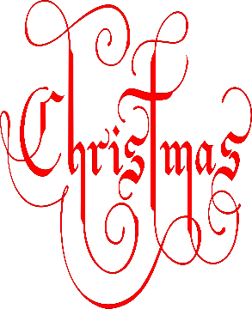
Christmas Raffle 2019

WINNers!!

Christmas Hamper includes a £50 voucher for M&S – Cara Greene
Wine and Cheese Hamper – Katie Mellors
£50 Meat Voucher – Elliot Drake
£50 Voucher for ‘Wine and Brine’ Moira – Harry Brown
£50 Voucher for ‘Refresh’ based in Edenmore Golf Club – Chris McDonald
£20 Voucher for ‘The Little Beauty Room’ Moira – Angela McNally
£20 Voucher for ‘Dough Bros’ Lisburn – Charlotte Hamilton
Christmas Eve Hamper – Leo McMullan
Christmas Colouring Hamper – Eve Parks
- Additional Prizes
- Michael Quinn
- Mia McMullan
- James Green
- John Cushnahan

