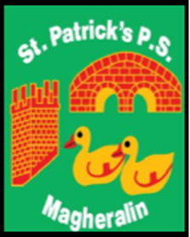

ST. PATRICK’S PRIMARY SCHOOL
12 Ballymacbredan Road, Magheralin, Craigavon. BT67 OQU
Tel no – 028 3834 1400 Fax no – 028 3834 7376
Email: info@stpatricks.magheralin.ni.sch.uk
Principal: Mrs. M. McGrath. BA(QTS), PQHSH, DipPD.
‘Together we learn, together we grow, developing our future, wherever we go!’

18th March 2020

Dear Parents

The advice from the Department of Education, is still, that schools will continue to remain open at this point.
We acknowledge, and are sympathetic, to parental concerns surrounding sending their children into school. Today we have approximately 30% of our school population present.

A decision has been taken to move a planned holiday at Easter to this week and to use our one remaining Staff Development Day to support closure to children on Thursday and Friday of this week.

As stated in our previous Update, schools will be instructed to close at some stage and that this may be for a prolonged period. We are, and have been actively planning for ways to support your children’s learning at home throughout this period of prolonged closure.

This is a continually changing situation and I will endeavour to keep you informed of any developments as soon as they arrive. We are in unprecedented circumstances and all schools are trying to make the best decisions in difficult times.

We continue, to work in partnership with you and our entire school community. We pray for the health and safety of all in our school community and beyond, in particular during this difficult and unsettling time for all.

Yours sincerely,
Mrs M. McGrath

