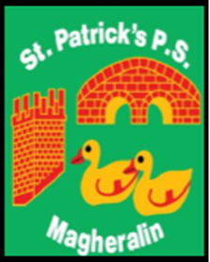

ST. PATRICK’S PRIMARY SCHOOL
12 Ballymacbredan Road, Magheralin, Craigavon. BT67 OQU
Tel no – 028 3834 1400 Fax no – 028 3834 7376
Email: info@stpatricks.magheralin.ni.sch.uk
Principal: Mrs. M. McGrath. BA(QTS), PQHSH, DipPD.
‘Together we learn, together we grow, developing our future, wherever we go!’

19/03/2020

Dear Parents,

The ‘Home Learning Packs’ will be ready for collection on Saturday between the times of

10.00am and 12.00noon

In order to ensure social distancing, I would ask you to adhere to the following times.

P1, P2, & P3: 10.00am-10.45am

P4 & P5: 10.30am-11.15am

P6 & P7: 11.15am-12.00noon

Learning Packs will be organised in classrooms for easy and quick distribution. Sibling packs can be collected at the same time in the classroom of your eldest child.

St. Patrick pray for us during these unprecedented times.

Yours sincerely,

Mrs. M. McGrath

