Free School Meals Payment Scheme
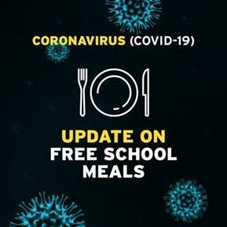
On 26 March, the Communities Minister Deirdre Hargey and Education Minister Peter Weir announced plans to make sure families do not experience hardship as a result of schools closing.
The new scheme will see the introduction of direct payments to families whose children would usually benefit from a school meal. Almost 97,000 children in Northern Ireland are entitled to free school meals.
Families will receive £2.70 per child per day for each day of term the schools are closed. This money will be paid to families on a fortnightly basis starting from Monday, 23 March. Payments will begin to reach bank accounts from 1st April. Please be patient as the Education Authority is working round the clock to ensure payments are made as soon as possible and it is expected that the majority of people entitled to free school meals will receive payment by Friday 3rd April 2020.
FREQUENTLY ASKED QUESTIONS

Q. How do I apply for this financial assistance?
A. There is no need to apply. For the vast majority of families the payment will come automatically into bank accounts. For those families for whom the Education Authority (EA) does not hold bank accounts, the EA will send out text messages early next week– only to those families. They will then be directed to an online form on the EA website. There is no need for anyone to contact the Education Authority.

Q. Why are you paying families for free school meals over the Easter holidays when children do not normally receive free school meals?
A. We recognise the urgency with which these payments are required and the proximity to the Easter holidays. In order to avoid any further hardship we took the decision to cover the Easter period as well.

Q. If schools are closed until June will the funding continue over the summer months?
A. It is not the intention to continue the funding over the summer holiday period. However, we do recognise the need for support for vulnerable children over holiday periods and there is a need for a wider strategic approach to deal with so called “holiday hunger” - that is something the Department for Communities will work through with the Department for Education over the coming weeks.

